**Professional experience**

LU1: Study Planning and Initial Analysis

Defining my study plan in the light of my personal history and goals, carrying out initial academic reading and analysis, and completing practical preparatory tasks.

David Norton

28/10/2013

Contents

Introduction 1

Placement 3

Goals & Objectives 5

Study Plan 8

Conclusion 9

Study Plan Calendar 10

Reflective Logbook 11

References 13

# Introduction

## About me

I am 21 and originally from Cranleigh, Surrey. I am currently working at IBM ion Southbank, London and living with my fiancé in Bromley. I have always been interested in computing, following my elder brothers who currently work at IBM and Atkins. I also have an interest in creative writing, having studied English Language at college, along with Computing, Physics and Math. I am currently looking at pursuing a career in computer security, but also have interests in web design and freelance writing.

## Academic Programme

I am currently studying Computer Security. I am interested in the problems security can cause in the computing industry and developing possible solutions. I enjoy the subject as it allows me to apply both my interest of computing with my written English language skills I developed both at college and while working as a freelance writer. I believe it will become an ever expanding problem, so is a good field to become specialized in.

Figure 1

Modules I have studied include: Software Design, Data Schemas and Applications, Computer Security and Forensic Tools, Computer and Network Security, Computer Networks and Operating Systems, Client-Server Programming, Computer Systems, Informing and Communicating in Practice, Analytical Modelling, Computer Crime and Digital Evidence and Systems Development.

## Career History

During secondary school I delivered papers for over three years and also volunteered working at Barnardo's for six months. I also spent two weeks working at a metal-works. This helped me to develop a range of different skills and decide what kind of career I would be interested in pursuing and the skills I would need to develop.

Figure 2

During college I spent a year working as a freelance writer working for an online company called Dominate Your Server to develop my English language skills further, gaining the job after writing the best article of over a hundred entries. It also helped to develop my communication skills as I had to work with my employer and others who were located all over the world.

 After college I took a gap year to experience the world and gain self-confidence. I spent several months volunteering in Madagascar, living in a forest with a small group of others from around the UK. I worked as a wildlife conservationist, cataloguing local wildlife and teaching the local community how to help conserve the local wildlife. I also spent nine months working in Australia on different farms. During this time I operated multi-million pound machinery from harvesting crops to constructing roads. I also lead a small to help repair flood damage over a 10,000 acre plot of land.

Figure 3



Figure 4

In my second year of university I worked as a web designer for a company called Nuke Arts. This helped me develop my knowledge for one of my modules and gave me an insight of what it would be like working as a web designer, which is still one of my interested career paths.

# File:IBM logo.svgPlacement

Figure 5

## Organisation

I am currently working as a Software Engineer at IBM in Southbank, London. IBM is a technology and consulting corporation and the 33rd largest globally firm, with nearly half a million employees worldwide. IBM is known for creating computer hardware and software, but also offers consulting, hosting and infrastructure services in ranging areas such as nanotechnology to mainframe computers. Their main competitors include HP, Accenture and Microsoft.

IBM has an organizational structure that is highly complex, and constantly adjusting to maintain maximum efficiency. .At the top is the CEO, who works alongside a board of directors that assist with everyday duties. Working under the CEO are a series of senior vice presidents, including Chief Financial Officer, Services VP and Software & Systems VP. From there, the corporate structure splits out across numerous divisions, each with its own organizational structure. Although the below diagram is not IBM’s organizational structure (after many hours of searching I have discovered none exist) the below shows a close representation, with a board of directors below the CEO, with many links crossing between different departments.

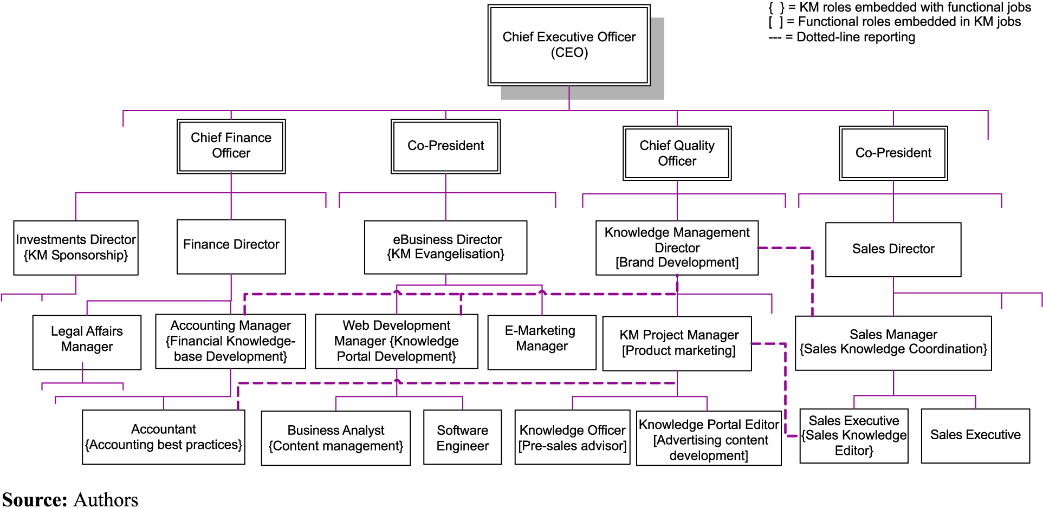

Figure 6

## Job Role

I work in the Web GUI department of the Tivoli Netcool OMNIbus product. Tivoli Software is a brand within IBM’s Cloud & Smarter Infrastructure division.

OMNIbus is a near real-time event management package that is used to monitor a business's infrastructure, such as data centers and networks. The software provides full management and automation to help the user maintain continuous uptime of business services and applications.

Web GUI is a front end display of OMNIbus that processes network events from one or more data sources and presents data in various graphical formats. It extends the capabilities of OMNIbus by being more configurable and remotely accessible through the Internet.

My role is to add additional functionality to Web GUI via side projects and key customer requests.

## Experiences So Far

### IBM Support Assistant Data Collection Tool (ISA DC)

I have taken lead of the ISA DC tool development for Web GUI. This is a web application tool that clients use when they have a problem with Web GUI and need to send relevant files to IBM to analyze. Rather than having a 30 minute phone call with the client discussing which files they need to put into a zip folder and send manually to IBM, they can now just fill in a couple of dialog boxes and the ISA DC tool will collect the correct files and send them to IBM automatically.

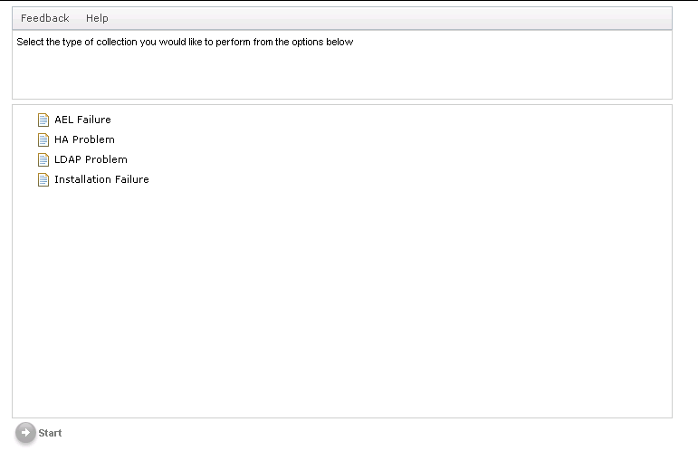Not only have I developed a new collector for a common error, but I largely improved upon the current collectors. I also commented all the code thoroughly, vastly improving understandability and reuse of the code for future development. I also documented the steps I took on a Wiki page, so anyone who has to develop the tool in the future will find it much easier.

Doing this required regular meetings with my mentor, the customer service team and other members of the Web GUI team. This involved planning and holding meetings with people all over the country as well as in America. I also ran demos to show how the tool works and request ideas for improvements.

ISA DC Tool Screenshot

### RFE

I have also been set to help develop solutions for the Request for Enhancement community. Clients use RFE to submit requests for improvements for IBM software. I am currently developing a solution to one of the major requests made by multiple clients to improve the Web GUI interface. This involves including icons to the main interface, and will be used by companies in the future including RBS, eBay, Vodafone, John Lewis, Virgin and many others.

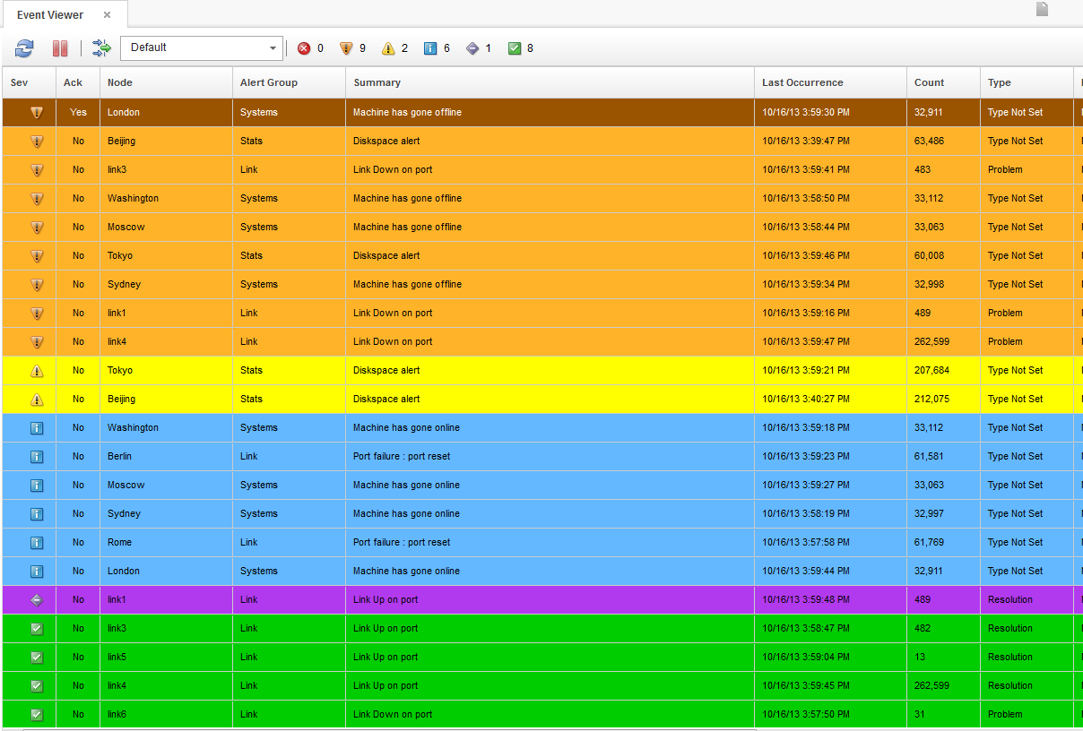This requires regular meetings with my mentor to discuss progression, as well as with other members of the Web GUI team to find out the best way to implement the new features required and to learn from their product knowledge.

OMNIbus Web GUI Screenshot

# Goals & Objectives

## Current Employability Skills

### Team Working

I feel being able to work as a team is by far the most important skill to have working in any environment. I have had a lot of experience to develop this skill, not only when working with others at university for projects and in my gap year leading and taking part in conservation work, but also at IBM. I am currently organizing weekly meetings to learn from the team how best to implement what I'm working on, with other regular chats to ensure I approach the problem in the best way.

### Motivation & Initiative

I have shown my motivation and initiative at IBM setting up a patent group, which we hold regular meetings for thinking up possible ideas. I have also set up a Java training session where we run through Java tests to improve our programming skills. I have kept these going for several months and pushed through several ideas that are currently being expanded upon.

### Problem Solving

I feel I have relatively good problem solving skills, as it is a key part of programming. It is also a key part of our patent meetings, as we come up with problems we currently have and think of the best ways they could be solved in a way that currently does not exist.

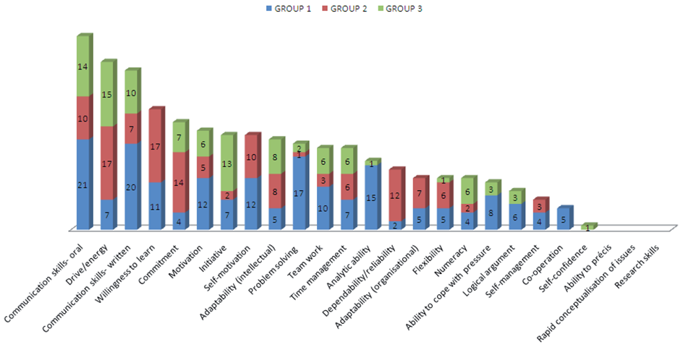

Figure 7

## Personal

I would like to improve upon my self-confidence skills. For example I still find it difficult asking people in meetings to repeat themselves if I miss what they say or approaching someone straight away if I need help. I would also like to improve my verbal communications skills, as I often find myself having difficultly transferring my thoughts to speech correctly. I think again this is a confidence issue, as I have no problem with this when using text.

To help me improve these skills on my placement, I will try to become more involved in the meetings I am involved in, as this will help me improve my communication skills. I will also focus more on talking to team members more in person, rather than online, as this should help improve my confidence. I feel having taken part in the meetings I have so far has already vastly developed both skills compared to what they were before the start of the year. I am currently signed up to give a presentation about IBM to UWE students in the coming month, something I would have never considered before starting at IBM.

Figure 8

## Placement

My initial goals for working at IBM was to improve my confidence, as mentioned above, and to take part in a major project that would be used by external customers. I have already begun work on this by adding icons to the main interface that companies such as eBay, Vodafone, RBS, AT&T and UPS.

I would also like to have a patent idea filed so that I can be classed as an inventor. I am holding weekly patent meetings and have developed several ideas so far to achieve this. I will have to ensure that these meetings stayed focused for the remaining time that I have left at IBM to successfully achieve this. Unfortunately due to time constrictions I may not find out if I achieve this before leaving IBM near the end of next year.

## http://www.totalcareersolutions.com/tcs/imgs/graduate.jpgFinal Year

Figure 9

My goal for the final year is to achieve a solid 1st result overall for my degree. I am already in a good position to achieve this, having achieved a first in my first and second year. To help achieve this I will work on my final year project while on placement to give myself more time to tackle the other modules in the final year to get the best results possible.

I also would like to learn a lot more on computer security, as currently I feel the first two years of university has been focused much more on forensics. This would ensure that I am well prepared when looking for a job in security after university, rather than leaving with pure computing skills. I will ensure that I take advantage of any opportunities that come up and do my own personal research before fishing the year.

## Career

I would ideally like to find a job in the computer security industry. Ideally I would be able to find a position doing this within IBM, as I have really enjoyed the environment and it is a good company to be a part of. Hopefully through my placement this year I can prove myself to obtain a permanent position with IBM. I will do this by taking part in as many activities as possible, ensure I keep regular communication with my team and ensure I keep my work at the highest possible quality while staying within deadlines.

Figure 10

## Professional Experience Module

I expect this module to help me understand the goals that I need to achieve throughout this year on my placement and keep me motivated to achieve them during my time here. I hope it will help me to more employable after my final year of university by giving me a better understanding of the workplace and developing my professional skills, knowledge and attitudes through reflective practice.

I also hope that it will help me to keep a log of my achievements while on placement that could help me apply for a job in the future. I am currently keeping a basic log of what I do each week, but this module could help me add a deeper layer of context to my notes.

# Study Plan

## Optional Learning Unit Choice

Having opened communication with another student for collaborating on a LU, I have decided to select **LU6: Teamworking and Project Management** as my optional learning unit. This will help me improve upon my team working and communications skills, as I believe these are the most important skills required in the work place. I also think due to the number of teams I work in I should be able to cover the subject much more in depth than others.

# Conclusion

I believe this LU has set me on the right path, as I now have a list of goals I want to tackle and I have a solid plan on how to achieve each one. It has helped give meaning to the record I have been keeping of my experiences and to give them context.

I think this module will require an extensive amount of work, so will require planning. I will repeat my approach that I took for this LU, as I was able to complete it well within the time desired and to a level I am happy with.

I will also be referring back to my Study Plan and Logbook to help me monitor my progress and help with further Learning Units.

**Word Count:** 2249

# Study Plan Calendar

|  |  |  |  |  |  |
| --- | --- | --- | --- | --- | --- |
| **UWE-FET UFCFE6-15-3 Professional Experience Module Calendar 2013/14 for** *[David Norton]* | | | | | |
| **UWE wk no**. | **Module wk. no.** | **Wk. comm.** | **Study Period (SP)** | **Learning Unit (LU) to be tackled** | **Notes**  **Milestones** |
| 9 | 1 | 23-Sep | Registration leeway period | |  |
| 10 | 2 | 30-Sep |
| 11 | 3 | 07-Oct | **SP1**  **(3 weeks)** |  | Due to course delays and tutors not being assigned, I will spend this time planning the required work **Ends Thu 24 Oct** |
| 12 | 4 | 14-Oct |
| 13 | 5 | 21-Oct |
| 14 | 6 | 28-Oct | **SP2**  **(3 weeks)** | *LU1* | I will complete LU1 and have it pre-marked by my tutor to avoid major mistakes, as I know I have time free over this time. **Ends Thu 14 Nov** |
| 15 | 7 | 04-Nov |
| 16 | 8 | 11-Nov |
| 17 | 9 | 18-Nov | **SP3**  **(3 weeks)** |  | I will likely be too busy with work this SP, but I will plan for LU5 and make contact for collaborative work. **Ends Thu 05 Dec** |
| 18 | 10 | 25-Nov |
| 19 | 11 | 02-Dec |
| 20 | 12 | 09-Dec | **SP4**  **(3 term weeks + 3 optional vacation weeks)** | *LU5* | This SP gives twice the time of the others, so it gives me the best advantage to complete another LU. I have chosen LU5, as it gives me more time to get the collaborative work needed for LU6. **Ends Thu 16 Jan** |
| 21 | UWE vacation | 16-Dec |
| 22 | 23-Dec |
| 23 | 30-Dec |
| 24 | 13 | 06-Jan |
| 25 | 14 | 13-Jan |
| 26 | 15 | 20-Jan | **SP5**  **(3 weeks)** |  | I will keep this SP free for a midway review, to ensure I am keeping up with my targets and deadlines, and adjust my plans if work isn’t being completed as expected .E**nds Thu 06 Feb** |
| 27 | 16 | 27-Jan |
| 28 | 17 | 03-Feb |
| 39 | 18 | 10-Feb | **SP6**  **(3 weeks)** | *LU6* | I will have had plenty of time to get the collaborative work by this SP, so is a good time to complete SP7. **Ends Thu 27 Feb** |
| 30 | 19 | 18-Feb |
| 31 | 20 | 24-Feb |
| 32 | 21 | 03-Mar | **SP7**  **(3 weeks)** |  | I will leave this SP free to plan as I have a holiday booked in this time and don’t want conflictions. **Ends** **Thu 20 Mar** |
| 33 | 22 | 10-Mar |
| 34 | 23 | 17-Mar |
| 35 | 24 | 24-Mar | **SP8**  **(3 weeks)** | *LU9* | Iwill complete the final LU in this SP, as it gives me full advantage of the time made available in the year. **Final deadline Thu 10 Apr 2pm** |
| 36 | 25 | 31-Mar |
| 37 | 26 | 07-Apr |

# Reflective Logbook

|  |  |  |
| --- | --- | --- |
| **UWE-FET UFCFE6-15-3 Professional Experience 2013-14 Reflective Logbook template** | | |
| **PROLUGUE** | **Student name**: David Norton | **SP #:** SP2 |
| **Employer:** IBM | **Date ending:** 14th November |
| **Tutor name:** Stewart Green | **LU #:** LU1 |
| **Overview:**  I have covered LU1 in this report. It links closely with the Personal Development Plan and Self-Assessment work I have covered at IBM.  It has required me to self-evaluate myself and use my planning skills in order to not let this module to affect my work, or my personal life too heavily. It has also required my research and organisational skills to assemble all the work required into an organised and complete piece. | |
| **PLAN** | I decided to cover LU1 in SP2, as the module was not ready in SP1, and it would give more time to read the module website and handbook to come up with a detailed plan on how I would tackle the required work. My aim was to create a list of objectives that I would like to achieve throughout the year, with a plan on how to tackle each, making them more realistic. I also wanted to make a record of my current achievements with evidence for each one.  As I was working on an important project at work, I had to set strict deadlines to work within to not become swamped. I planned to complete this LU early into SP2 before becoming overloaded. I first read through the handbook and the entirety of the website several times over a week, as planned, and made notes on anything I thought relevant to LU1. I then arranged each point into sections and set deadlines to complete each section by.  To meet certain deadlines quickly, I planned to reuse text in my Personal Development Plan and Self-Assessment Wiki. I still had to research IBM’s organization structure, as I had only focused on how the London office is run. I was able to find this information via Google and using IBM’s private Intranet. It was interesting to see how different IBM runs compared to different companies.  I also spent time considering my current employability skills and the areas I need to improve. I used the ‘Skills Development’ tab on the module website to help me with this, along with many other websites online, as there are many different opinions on which are the most important. | |
|
|
|
| **ACTION** | To track the implementation of my study plan, I have my Calendar printed at home and stuck on the wall, so I can refer to it each day. For this LU, I created a bullet point list of requirements, so as not to miss anything out, and assigned each point with a due date. I will be using this system again for my next LU, as it has worked well, allowing me to constantly review my progress.  I was able to get ahead early having a large amount of the LU already written and having a solid plan to follow. However my time became constrained by work deadlines, I started to fall behind my schedule of having my first draft complete by the end of October. I had planned to dedicate the first weekend in November to catch up, but with the hurricane on the 28th October, I was unable to travel to work, so I utilized my time to complete it early.  During my time at IBM I have learnt to add a contingency plan to anything I work on. Even though I could have fallen behind at this point, I had a week set free before the deadline in which I could recover. This made the experience of falling behind schedule much less stressful. | |
| **REVIEW** | I sent my initial draft to my tutor on the 28th October, leaving over two weeks to receive a response and make relevant changes. This allowed me to fully concentrate on work, taking away pressure early on, giving more time to plan for future LUs. I’m glad I gave such a large contingency time period, as it meant falling behind my deadlines didn’t become a problem.  I feel reusing past work worked extremely well, as it allowed me to complete the LU far earlier than otherwise possible. Having key points noted early also saved me having to reread the large amounts of text available on this module.  It was surprising how focused IBM is towards helping employees gain the skills discussed in this LU, via Giveback opportunities, Personal Development System and many other activities offered. | |
| **REFLECTION** | To improve on the plan I created for the next LU, I will collaborate with other students to see how they interpreted the assigned work to ensure I cover the requirements as fully as possible. I will also dedicate more time to research, as it can be time consuming when having to use referencing.  This LU, along with my work at IBM, has shown me it is important to improve my self-confidence and communication skills. As a result of this, I decided to come back to UWE in November and give a presentation to potential placement students about what a placement is like with IBM.  I am fortunate enough to have already taken on a large project that will be used by large companies, and I’m also glad that I have already been able to form a patent group.  As another result of this module, I have become more inclined to apply for security based events and have attended an Ethical Hacking event at Kings College London, and plan to attend more so that I am able to host the event myself before leaving IBM. | |
| **EPILOGUE** | I am pleased that I was able to meet my deadline without needing to use any of my contingency time. I am also very happy that this LU has got me motivated to achieve my goals, not only by presenting at UWE, but by improving my security and communication skills at a yearlong ethical hacking event.  I will now begin planning my next LU so that I am as well prepared as I was for this one. I will also start collaborating with other students so that I can improve on my next LU and hopefully offer more scope in my report. | |

# References

## Images

1. SMALLBUSINESSINDIA (February 19th, 2012) Computer Security [electronic]. At: Intuit Small Buisness India Blog. Available from: <http://smallbusinessindia.intuit.in/technology/computer-security-small-business> [Accessed 27/10/2013].
2. THEDRUM (c. 2000-11) Banardo’s Logo [electronic]. At: THEDRUM website. Available from: <http://www.thedrum.com/news/2011/11/04/reading-room-host-exhibition-aid-barnardos> [Accessed 27/10/2013].
3. RealGap (c. 2000-13) Planning a Gap Year [electronic]. At: RealGap website. Available from: <http://www.realgap.co.uk/gap-travel-advice/planning-gap-year> [Accessed 27/10/2013].
4. FERNANDO BIZ (August 18, 2013) Web Design [electronic]. At: FERNANDO BIZ. Available from: <http://www.fernandobiz.com/content-marketing-and-web-design> [Accessed 27/10/2013].
5. IBM (1972) IBM Logo [electronic]. At: IBM Website. Available from: <http://www.ibm.com/us/en/> [Accessed 27/10/2013].
6. Emerald Insight (22/10/13) Emerald | How to develop knowledge [electronic]. At: Emerald Insight Website. Available from: <http://www.emeraldinsight.com/journals.htm?articleid=1562720&show=html> [Accessed 13/11/2013].
7. Brunel University (2011) Graduate skills chart [electronic]. At: Brunel University Website. Available from: <http://www.brunel.ac.uk/services/pcc/students/make-yourself-employable/developing-skills> [Accessed 28/10/2013].
8. Breathezy (c. 2012-2013) Self-Confience [electronic]. At: breathezy Website. Available from: <http://www.breathezy.com/building-self-confidence/> [Accessed 28/10/2013].
9. Total Career Solutions (c. 2010-2013) Graduate [electronic]. At: Total Career Solutions Website. Available from: <http://www.totalcareersolutions.com/graduate-career-advice.aspx> [Accessed 28/10/2013].
10. CAREEREALISM (July 16, 2010) Critical Steps in Your Career Transition [electronic]. At: CAREEREALISMWebsite. Available from: http://www.careerealism.com/critical-steps-career-transition [Accessed 28/10/2013].

## text based

I have split my references into two sections. References 1-9 cover the research I undertook for reflective practice, while 10+ refer to the reading I did on business analysis. The first three references are my own work, where I have recorded my past achievements both for my own benefit and for work.

The following reflective practice references cover a select few websites that cover different personal skills or focus importance in different areas. Many websites are similar, but I felt these each offered something unique. My business analysis covered the organizational structure of the company, its history and the department that I work within.

1. David Norton (2013) CV, not available, personal file [Accessed 22/10/2013]
2. David Norton (2013) IBM Personal Development Plan, personal file [Accessed 22/10/2013]
3. David Norton (2013 IBM Self-Assessment Wiki Page, personal file [Accessed 23/10/2013]
4. UWE (c. 2010 - 2013) iSkillZone Available from: <http://iskillzone.uwe.ac.uk/RenderPages/RenderHomePage.aspx> [Accessed 24/10/2013].
5. Skills4Study (c. 2011 - 2013) SkillsForStudyCampus Available from: <http://www.skills4studycampus.com/StudentHome.aspx> [Accessed 24/10/2013].
6. StudyMode (May 2013) Employeability Skills.  Available from: <http://www.studymode.com/essays/Employeability-Skills-1661697.html> [Accessed 24/10/2013].
7. University of Kent (2013) What are the top ten skills that employers want? Available from: <http://www.kent.ac.uk/careers/sk/top-ten-skills.htm> [Accessed 24/10/2013].
8. Target Jobs (c. 2018 - 2013) The top 10 skills that'll get you a job when you graduate Available from: <http://targetjobs.co.uk/careers-advice/career-planning/273051-the-top-10-skills-thatll-get-you-a-job-when-you-graduate> [Accessed 25/10/2013].
9. SkillsYouNeed (c. 2011 - 2013) Employability Skills | Skills You Need for a Job Available from: <http://www.skillsyouneed.com/general/employability-skills.html> [Accessed 25/10/2013].
10. Sebastin A (c, 2008-2012) Ibm Organizational Structure Available from: http://www.reference.com/motif/food_and_drinks/ibm-organizational-structure [Accessed 27/10/2013].
11. Wikipedia (c, 2007-2013) IBM Available from: http://en.wikipedia.org/wiki/IBM [Accessed 27/10/2013].
12. IBM (c, 2010-2013) Tivoli Netcool/OMNIbus Available from: http://www-03.ibm.com/software/products/us/en/ibmtivolinetcoolomnibus/ [Accessed 27/10/2013].